Functional Test Report
Inji Mobile Wallet 0.21.0

10 December 2025


Document History
It outlines the strategy used to ensure a comprehensive evaluation.

Version | Author | Date | Review | Affected Sections
V1.0 | Nitin Hegde | 10/12/2025 | - Chaitanya Kesiraju  - Ragini Krishna | New Document

Contents

1 Introduction 4
1.1 Overview and Scope 4
1.1.1 Authentication & Security 4
1.1.2 Credential Management (Download & Storage) 4
1.1.3 Credential Usage & Sharing 5
1.1.4 User Experience & Navigation 5
2 Test Approach 5
3 Test Organization 5
3.1 Test Planning 6
3.2 Test Devices 6
3.3 Test Environment 7
4 Test Execution Report 7
4.1 Test case execution summary 7
4.2 Combination Testing with device components 8
4.3 Automation Result VC verifier 8
4.4 Automation Result Mimoto API 9
5 Defect Metrics 10
5.1 Defect Metrics for the Release 0.21.0 10
5.2 Known Issues Metrics 10
6 Conclusion 11
6.1 QA Approval 11
7 Appendix 12
7.1 Appendix A: Versions 12
7.2 Appendix B: Acronyms 12

Introduction
The scope of testing is to verify fitment to the specification from the perspective of Functionality, Configurability and Customizability. Verification is performed not only from the end-user perspective but also from the System Integrator (SI) point of view. Hence, the Configurability and Extensibility of the software are also assessed. This ensures the readiness of the software for use in multiple countries and diverse identity ecosystems.

Overview and Scope

1.1.1 Authentication & Security
- Biometric unlock: Verify app access using device-registered biometrics (fingerprint/face) and the fallback to passcode if biometric disabled.
- Passcodes unlock: Validate the setup, verification of a numeric PIN for securing app access.
- Key Management: Validate the rotation of keys within the device's with drag and drop options from application.
- Wallet binding: Validate that the wallet binding (vc activation) and its credentials are securely bound to the specific device.
- Logout: Verify that logging out clears the active session and requires re-authentication to re-enter the application.

1.1.2 Credential Management (Download & Storage)
- VC download via MOSIP: Test fetching credentials using a UIN or VID with OTP authentication against the MOSIP backend.
- VC downloads via Sunbird: Test the successful download and rendering of credentials from Sunbird RC-based registries.
- Credential Offer: Test the end-to-end flow of receiving a credential offer via QR and initiating the issuance process.
- SD JWT VC download: Verify the download and selective disclosure capabilities of credentials in SD-JWT format.
- SVG VC download: Check the download and correct visual rendering of credentials using dynamic SVG templates defined by the issuer.
- Credential registry: Verify the wallet's ability to fetch and display trusted issuers and their metadata from the central registry.
- Backup and restore: Test the backup of credentials to cloud storage and their successful restoration on a new device.
- Deleting VC: Validate the permanent removal of a credential from the wallet and UI.

1.1.3 Credential Usage & Sharing
- BLE (offline) VC sharing: Share VCs offline using Bluetooth Low Energy with face auth and with fingerprint biometric authentication.
- Pinning a VC: Verify the functionality to pin frequently used credentials to the top of the home screen for quick access.
- OpenID4VP: Test the online presentation and sharing of credentials to a verifier using the standard OpenID for Verifiable Presentations flow.
- QR code Login: Verify using the wallet to scan a QR code and authenticate user login for third-party Relying Parties.

1.1.4 User Experience & Navigation
- Multi language support: Check UI rendering, label translations, and layout stability across all supported languages (Kannada, Hindi, Tamil, Arabic, Filipino and English).
- Deep link navigation (same device flow): Verify that external links (e.g., inji://) correctly open the app and navigate to specific screens.

Test Approach
The Functional verification of the Inji Mobile Wallet application is performed on Android and iOS platforms to ensure alignment with product specifications and business requirements. Analyzed with respect to functional stability, data integrity, and UI consistency. The validation adopts a persona-based testing strategy, simulating real-world user scenarios across diverse device matrices and multi-language configurations to ensure robustness in both online and offline environments.

Functionality
Combination
Configurability
Customizability
Library verification (vc-verifier)

Test Organization
Table 1: Test Organization
Name | Functional Role | Responsibilities
Aswin | QA Engineer | Verifying the functionality, stability of the application, and performing combination testing.
Nitin Hegde | QA Lead | Verifying the functionality, stability of the application, and report preparation.
Chaitanya K | QA Manager | Overviewing the test execution and review of report.
Ragini Krishna | Senior QA Manager | High-level governance and executive reviews of reports and execution.

Test Planning
- Data Readiness: Validate the availability of all services along with configured identity schemas (UIN/VID) to support biometric and authentication flows.
- Data Strategy: Refresh test data for every cycle by generating new QR codes for credential offers and preparing specific datasets for Sunbird/e-Signet integrations.
- Coverage Distribution: Distribute test scenarios across a diverse matrix of Android and iOS devices and distinct user personas to ensure comprehensive compatibility coverage.

Test Devices
Table 2: Test Devices
Device Model | OS and BLE version
iPhone 7 | iOS 15.8 BLE 4.2
iPhone 11 | iOS 26.1 BLE 5.0
iPhone 13 | iOS 18.6.2 BLE 5.0
iPhone 14 | iOS 26.2 BLE 5.3
SS Galaxy A03 core | Android 11 BLE 4.2
Vivo Y73 | Android 13 BLE 5.0
Redmi 6A | Android 9 BLE 4.2
Techno POVA 6 NEO | Android 14 BLE 5.0
OPPO A59 5G | Android 13 BLE 5.3
ONE PLUS 12R | Android 15 BLE 5.3
Infinix NOTE 50X 5G | Android 15 BLE 5.4
Redmi 7A | Android 10 BLE 4.2
iTel | Android 14 BLE 5.0
Xiaomi Redmi NOTE 13 Pro | Android 15 BLE 5.2

Test Environment
Table 3: Test Environment
Images (qa-inji1 env)
mosipqa/inji-verify-service:0.16.x
mosipqa/inji-verify-ui:0.16.x
mosipqa/inji-certify-with-plugins:0.13.x
mosipid/apitest-mimoto:0.20.0
mosipqa/mimoto:develop
mosipqa/inji-web:develop

Images (released env)
mosipid/mimoto:0.20.0
mosipid/apitest-mimoto:0.20.0
mosipid/inji-verify-service:0.15.2
mosipid/inji-verify-ui:0.15.2
mosipid/inji-certify-with-plugins:0.13.1
mosipid/inji-web:0.15.0
mosipid/esignet-with-plugins:1.6.2
mosipid/authentication-service:1.2.1.0
mosipid/authentication-internal-service:1.2.1.0
mosipid/authentication-otp-service:1.2.1.0
mosipid/kernel-notification-service:1.2.0.1
mosipid/registration-processor-stage-group-1:1.2.1.1

Test Execution Report

Test case execution summary
Table 4: Test Execution Summary
Platform | Total | Pass | Fail | Skip
Android | 2187 | 2017 | 170 | 0
iOS | 2020 | 1846 | 174 | 0
Total | 4207 | 3863 | 344 | 0
Test cases: 4207 Passed: 3863 Failed: 344 Skipped: 0
Test Rate: 100% With Pass Rate: 91%

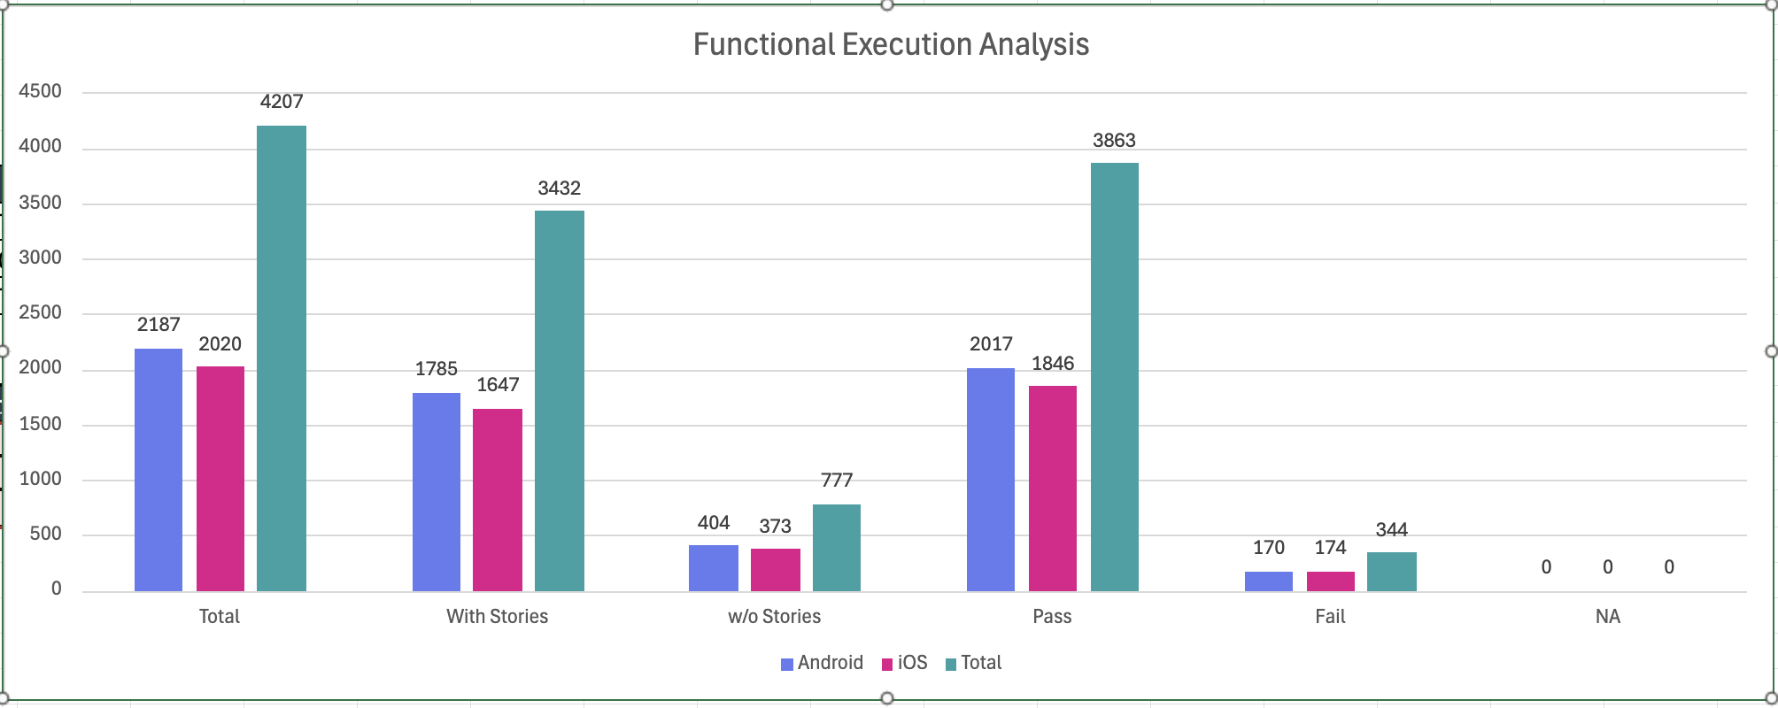

Combination Testing with device components
This section details Combination Testing results for Inji Mobile on Android and iOS, specifically validating workflows like sharing Verifiable Credentials (VCs) across devices. These tests confirm the application's stability when orchestrating multiple components such as Bluetooth, camera, and biometrics during these cross-platform interactions.
Table 5: Combination Result
Total | Passed | Failed | Skip
Total | 192 | 29 | 0
Test Rate: 100% With Pass Rate: 84.89%

Automation Result VC verifier
Table 6: VC Verifier Library
Total | Pass | Fail | Known Issues | Ignored
155 | 118 | 37 | 0 | 0
Test Rate: 100% With Pass Rate: 76.12%

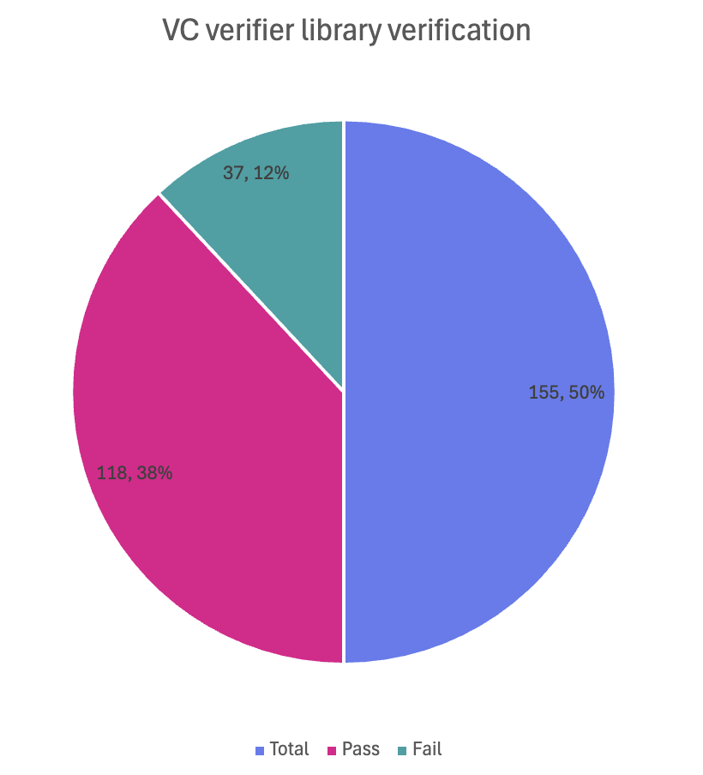

Automation Result Mimoto API
Table 7: Mimoto API Automation Result
Total | Pass | Fail | Known Issues | Ignored
349 | 312 | 0 | 4 | 33
Test Rate: 100% With Pass Rate: 89%

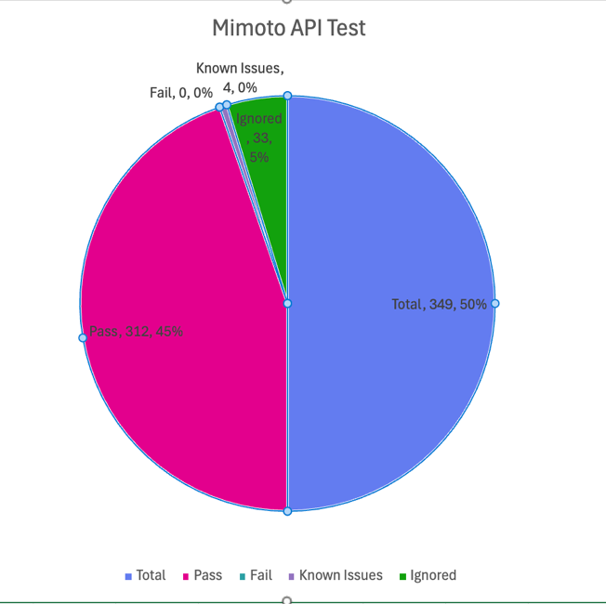

Defect Metrics

Defect Metrics for the Release 0.21.0
The following table depicts only the bugs which are found and not addressed in the current release.
Table 8: Defect Metrics for the Release
Blocker | Critical | Major | Minor | Total
0 | 0 | 8 | 4 | 20

Known Issues Metrics
This section focuses on a separate category of issues that are known but not addressed in the current release. It provides a count and severity distribution for these defects across releases.
Table 9: Defect Metrics for the known issues
Blocker | Critical | Major | Minor | Total
0 | 0 | 167 | 43 | 210

Known Issues Table Representation Chart
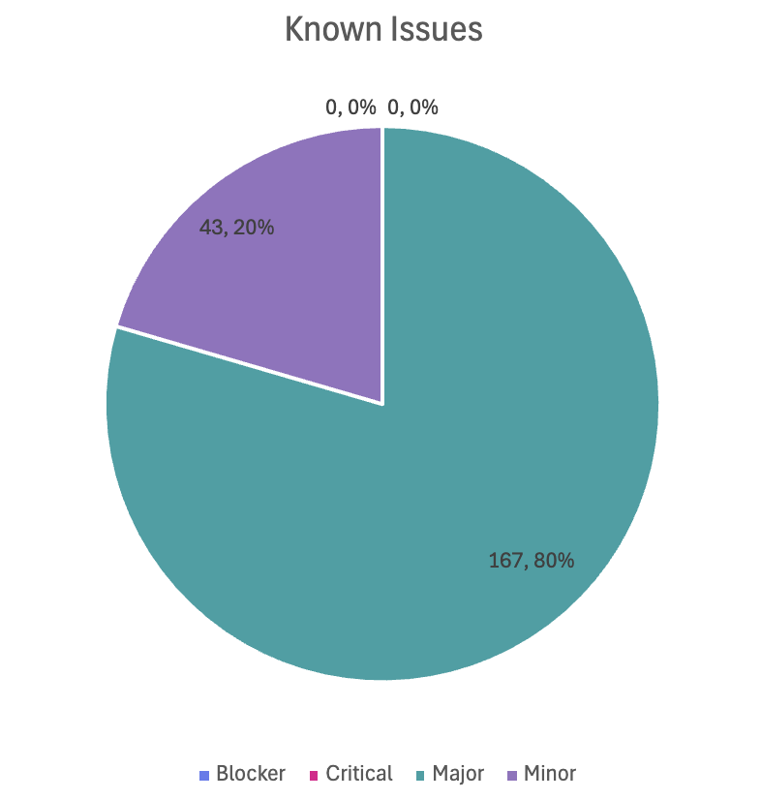

Conclusion
This section summarizes the key findings of test execution. It also provides a final QA recommendation on the build's readiness for release. The functional verification for Inji Mobile Wallet version 0.21.0 has been successfully completed across Android and iOS platforms. The testing cycle achieved a 100% execution rate with a 91% pass rate across a total of 4,207 test cases. Additionally, API automation via Mimoto achieved a 100% pass rate.
While there are 20 open defects (8 Critical, 8 Major, 4 Minor) and 210 known issues, there are zero blocker defects identified. The application has demonstrated functional stability and data integrity consistent with product specifications.

QA Approval
The build has successfully met the defined exit criteria and is recommended for release. The approval is based on the following satisfied conditions:
- Test Case Execution Completion: 100% of planned scenarios executed.
- Defect Status: No Blocker defects remain open.
- Documentation Sign-off: All test artifacts and reports are finalized.
- Test Environment Stability: The test environment remained stable throughout the execution cycle.

Table 10: Report is signed off details
Name | Functional Role | Responsibilities
Chaitanya K | QA Manager
Ragini Krishna | Senior QA Manager

Appendix
This includes additional reference information for the report. It contains a history of document versions and a list of acronyms and their meanings.

Appendix A: Versions
 | Date | Author | Reviewers
V1.0 | 10/12/2025 | Nitin Hegde | Chaitanya K  Ragini Krishna

Appendix B: Acronyms
Acronym | Literal Translation
MOSIP | Modular Open Source Identity Platform
UIN | Unique Identification Number
VID | Virtual Identification
SVG | Scalable Vector Graphics
SD-JWT | Selective Disclosure - JSON Web Token
VC | Verifiable Credentials
OpenID4VP | OpenID for Verifiable Presentations

END OF DOCUMENT

